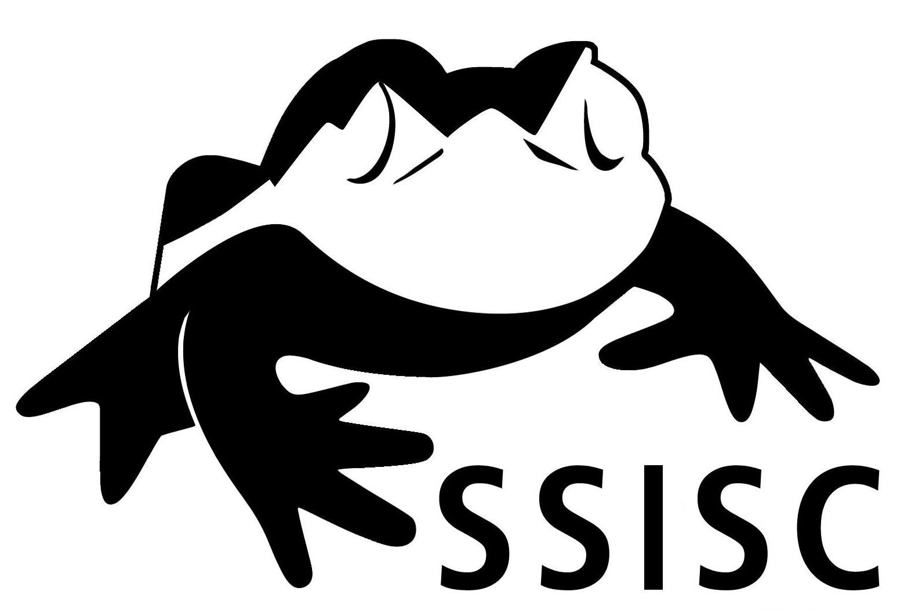
Sea to Sky Invasive Species Council

SSISC's 2023 Annual General Meeting and Land Manager Planning Session
AGENDA
10:30pm – 12:30pm, Wednesday April 19th, 2023
Via Zoom Conference Call
More information, and meeting materials here: https://ssisc.ca/2023agm
PLEASE REGISTER in advance here: https://us06web.zoom.us/meeting/register/tZAlc-CtqDwiHdBNVgckBZh78CMJLM88mLcK
10:30 | Welcome  Leslie Anthony, Chair - SSISC
10:35 | Invasive Species Management in the Sea to Sky Region - Year in Review & Plans for 2023  - Clare Greenberg, Executive Director, SSISC  - Claude-Anne Godbout-Gauthier, Education & Outreach Manager, SSISC  - Erin Galloway, Field Crew Manager, SSISC
10:55 | Guest Speaker (TBC)
11:15 | AGM:  - Review of 2022 AGM Minutes  - Financial Report 2022 (Caroline Ashekian – Treasurer)  - Election of 2023 Directors
11:25 | Land Managers & Funders Planning Session*:  - Review of changes to Regional Species Priority Lists (Plants)  - Round-table updates (max 2 mins per partner)  - 2023 Annual Program Plan  - 2023 Proposed Budget
12:15 | Questions & Discussion
12:25 | Closing Remarks  Leslie Anthony, Chair - SSISC

*The Land Managers & Funders Planning Session section of the agenda, is primarily an opportunity for the SSISC’s partners to provide input and feedback on SSISC’s proposed strategic, operational and annual plans for 2022, however all SSISC members are welcome to attend.

